Visualize data with Python : From finance to journalism, data is the key to making compelling arguments and telling great stories. Learn how to create powerful data visualizations with Python, the fastest-growing programming language in the world.

Case Study : India Temples Data Generated from Python Program

Purpose : Generating the India’s Famous Temples data from Google for Data Analytics

Developed by GCP Guild Members, Kyndryl. **Date :** Wednesday, June 8, 2022

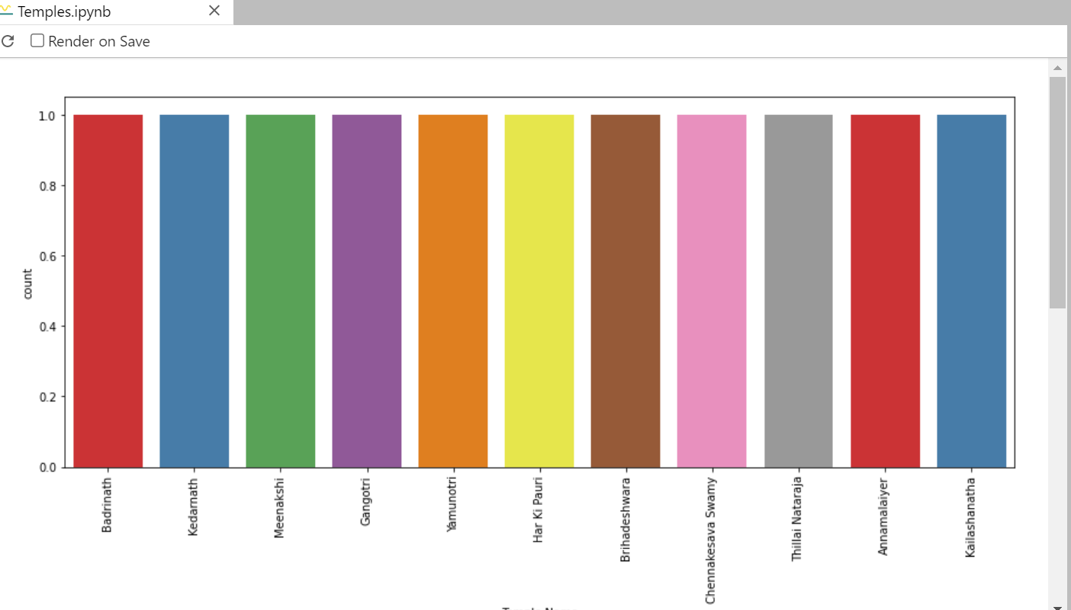

Santosh Baran <Santosh.Baran@kyndryl.com>

Ramamurthy Valavandan <[Ramamurthy.Valavandan@kyndryl.com](mailto:Ramamurthy.Valavandan@kyndryl.com)>

Musheer Ahmed N <[Musheer.Ahmed.N@kyndryl.com](mailto:Musheer.Ahmed.N@kyndryl.com)>

Prasanth Parayatham <[Prasanth.Parayatham@kyndryl.com](mailto:Prasanth.Parayatham@kyndryl.com)>

Kumaraswamy Reddy <[Kumaraswamy.Yanamala@kyndryl.com](mailto:Kumaraswamy.Yanamala@kyndryl.com)>

Pallav Kohli <[Pallav.Kohli@kyndryl.com](mailto:Pallav.Kohli@kyndryl.com)>

Surasa Mukherjee <[Surasa.Mukherjee@kyndryl.com](mailto:Surasa.Mukherjee@kyndryl.com)>

Vikram Sharma <[Vikram.Sharma1@kyndryl.com](mailto:Vikram.Sharma1@kyndryl.com)>

Dinesh Sai Teja Neeli <DINESH.SAI.TEJA.Neeli@kyndryl.com>

Vijay . <[Vijay.R1@kyndryl.com](mailto:Vijay.R1@kyndryl.com)>

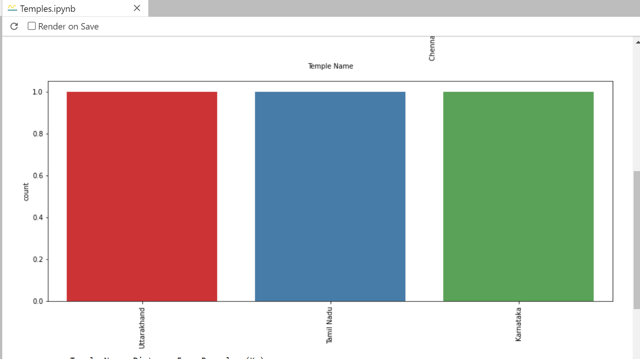

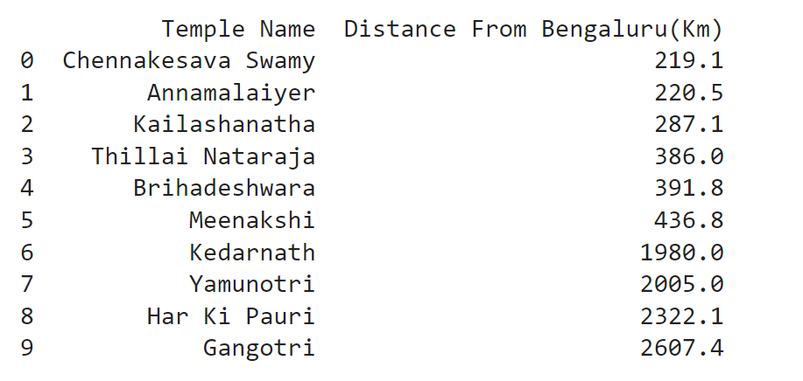

What the Google Connect Provide

1. Connect to Google and Generate the data of Temples in India
2. Filters the data in the data analytics able to understand and generate the csv data
3. Connect to the Google and get the appropriate information for the Data Analytics engine
4. Generate the Data Visualization for the consumer to understand data in a better way.

Pre requirements

Follow this document for installation of the required modules

[India Temples Data Generated from Python Program.docx](https://kyndryl.sharepoint.com/:w:/r/sites/GoogleAllianceCommunity/Shared%20Documents/General/Google%20Connect/India%20Temples%20Data%20Generated%20from%20Python%20Program.docx?d=w74c521272ea84b3b9cdb5afe1e07081e&csf=1&web=1&e=KATZNQ)

python checkmodule.py

This utility to help to install required modules

Download from Kyndryl Share point

[googledata.py](https://kyndryl.sharepoint.com/:u:/r/sites/GoogleAllianceCommunity/Shared%20Documents/General/Google%20Connect/googledata.py?csf=1&web=1&e=i9ar0C)

[Temple Data Generation](https://kyndryl.sharepoint.com/:f:/r/sites/GoogleAllianceCommunity/Shared%20Documents/GCP%20Guild%20Use%20Cases/Googling%20Data%20Sheet%20-%20Python/Python%20for%20Google/Temple%20Data%20Generation?csf=1&web=1&e=dyl7vV)

[templesview.py](https://kyndryl.sharepoint.com/:u:/r/sites/GoogleAllianceCommunity/Shared%20Documents/General/Google%20Connect/templesview.py?csf=1&web=1&e=ISFhgw)

[Temples.ipynb](https://kyndryl.sharepoint.com/:u:/r/sites/GoogleAllianceCommunity/Shared%20Documents/General/Google%20Connect/Temples.ipynb?csf=1&web=1&e=O8943P)

Execute the program :

python googledata.py <http://www.walkthroughindia.com/hindu-temple/top-25-popular-hindu-temples-tamil-nadu/>

Data generated :

|  |
| --- |
| T o p 2 5 M o s t P o p u l a r H i n d u T e m p l e s o f T a m i l N a d u |
| Brihadeeswarar Temple| Thanjavur |
| Meenakshi Amman Temple| Madurai |
| Shore Temple| Mamallapuram |
| Annamalaiyar Temple| Tiruvannamalai |
| Gangaikonda Cholapuram| Thanjavur |
| Ramanathaswamy Temple| Rameswaram |
| Ucchi Pillayar Temple| Rockfort |
| Murugan Temple| Tiruchendur |
| Ranganathaswamy Temple| Srirangam |
| Thillai Nataraja Temple| Chidambaram |
| Jambukeswarar Temple| Thiruvanaikaval |
| Uppiliappan Temple| Thirunageswaram |
| Ekambareswarar Temple| Kanchipuram |
| Tirunallar Saniswaran Temple| Thirunallar |
| Subramanya Swamy Temple| Pachaimalai |
| Bannari Amman Temple| Sathyamangalam |
| Thyagaraja Temple| Tiruvarur |
| Kailasanathar Temple| Kanchi |
| Anjaneya Swamy Temple| Namakkal |
| Palani Murugan Temple| Palani |
| Lakshmi Narsimha Swamy Temple| Vellor |
| Kumari Amman Temple| Kanyakumari |
| Kamakshi Amman Temple| Kanchipuram |
| Panchamukha Anjaneyar Temple| Tiruvallur |
| Mondaicaud Bhagavathi Temple| Kanyakumari |

Result



python generatetempledata.py

Result

Data generated by Google Connect

|  |  |  |  |  |  |
| --- | --- | --- | --- | --- | --- |
| Temple Name | State | Location | Coordinates | Distance From Mumbai(Km) | Distance From NewDelhi(Km) |
| Badrinath | Uttarakhand | Badrinath | (30.7433,79.4938) | 1914.7 | 530.1 |
| Kedarnath | Uttarakhand | Kedarnath | (30.7346,79.0669) | 1437 | 296 |
| Meenakshi | Tamil Nadu | Madurai | ( 9.919, 78.11953) | 1425.3 | 2586.8 |
| Gangotri | Uttarakhand | Gangotri | (30.9947,78.9398) | 1888.8 | 504.1 |
| Yamunotri | Uttarakhand | Yamunotri | (31.0140,78.4600) | 1438 | 291 |
| Har Ki Pauri | Uttarakhand | Haridwar | (29.9457,78.1642) | 1603.5 | 218.8 |
| Brihadeshwara | Tamil Nadu | Thanjavur | (10.7870,79.1378) | 1383.5 | 2523 |
| Chennakesava Swamy | Karnataka | Belur | (13.1623,75.8679) | 896.3 | 2147 |
| Thillai Nataraja | Tamil Nadu | Chidambaram | (11.398, 79.695) | 1377.7 | 2408.7 |
| Annamalaiyer | Tamil Nadu | Thiruvannamalai | (12.228, 79.066) | 1200.1 | 2281.9 |
| Kailashanatha | Tamil Nadu | Kanchipuram | (12.8185,79.6947) | 1274.7 | 2257.2 |

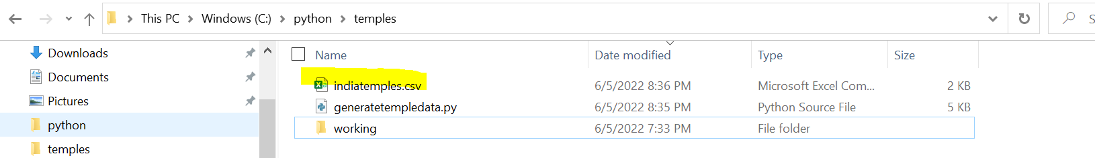

cd C:\python\temples

jupyter-lab

c:\python\temples>jupyter-lab Temples.ipynb

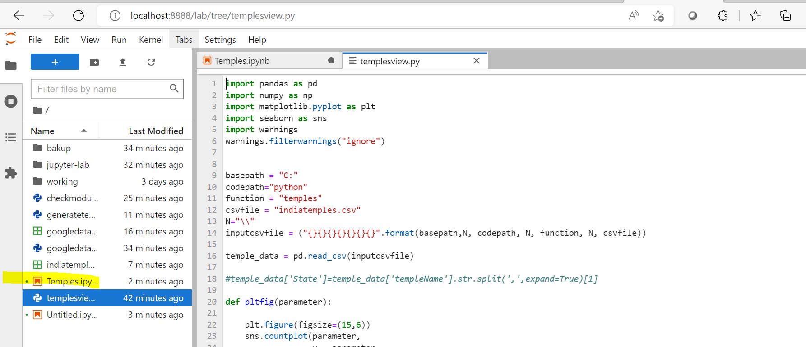

Click voila

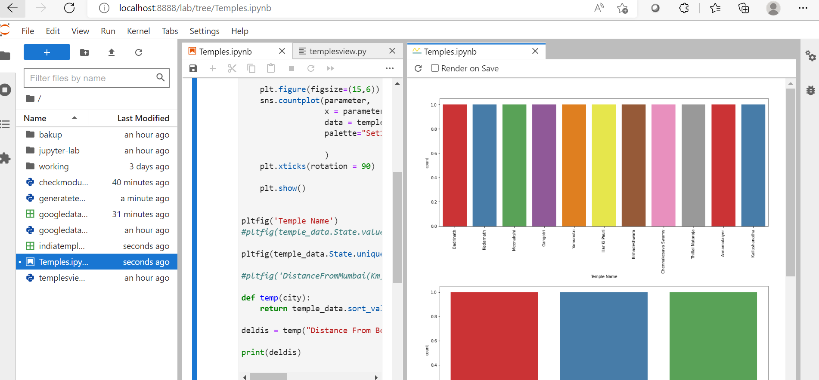

Appendix

Help documents

[Google Connect.docx](https://kyndryl.sharepoint.com/:w:/r/sites/GoogleAllianceCommunity/Shared%20Documents/General/Google%20Connect/Google%20Connect.docx?d=w1eb2fa414e9243c6a4fc1734b40c307c&csf=1&web=1&e=WuYNAV)

<https://kyndryl.sharepoint.com/:w:/r/sites/GoogleAllianceCommunity/Shared%20Documents/General/Google%20Connect/Google%20Connect.docx?d=w1eb2fa414e9243c6a4fc1734b40c307c&csf=1&web=1&e=WuYNAV>

[Check the required modules.docx](https://kyndryl.sharepoint.com/:w:/r/sites/GoogleAllianceCommunity/Shared%20Documents/General/Google%20Connect/Check%20the%20required%20modules.docx?d=w708ce06dd29d4d2e8547528244db51ed&csf=1&web=1&e=6e3LuD)

<https://kyndryl.sharepoint.com/:w:/r/sites/GoogleAllianceCommunity/Shared%20Documents/General/Google%20Connect/Check%20the%20required%20modules.docx?d=w708ce06dd29d4d2e8547528244db51ed&csf=1&web=1&e=6e3LuD>